**Task 4 (5%) Electrochemical Cells Extended Response Name: ____________________**

**Question 1**

The Daniell cell was invented in 1836 and was one of the earliest batteries to be designed. Essentially, the Daniell cell can be thought of as two half-cells consisting of a copper electrode submerged in copper(II) sulfate solution (Cu/Cu2+) and a zinc electrode submerged in zinc sulfate solution (Zn/Zn2+). In the original design, a porous clay pot was used to separate the half-cells and act as what we now call the salt bridge. The EMF produced by the Daniell cell is 1.1 V under standard conditions.

A chemistry class was studying the basic design of the Daniell cell and decided to investigate the effect of changing the metals used for each electrode/electrolyte. They decided to construct a cell using tin metal, chromium metal, tin(II) sulfate solution and chromium(III) sulfate solution. They set up their apparatus as shown in the diagram below.

Cation flow

Electron flow

Substance:

***Chromium***

Substance:

Electrode:

Sign:

Substance:

***Tin***

Substance:

Electrode:

Sign:

V

(a) Label all remaining components of the cell in the diagram above, including: **(6 marks)**

(i) cathode and anode

(ii) sign of each electrode

(iii) substance used for each half-cell electrolyte

(iv) direction of electron and cation flow

(b) Note two observations that would be made as this electrochemical cell operates. **(2 marks)**

________________________________________________________________________

________________________________________________________________________

The overall equation for the operation of this electrochemical cell is;

3 Sn2+ (aq) + 2 Cr(s) → 3 Sn(s) + 2 Cr3+(aq)

Just like the Daniell cell, the cell designed by the students is a primary cell, which means it cannot be recharged. Therefore, over time the reactants will run out, as the chemicals stored within the electrochemical cell are used to produce electricity.

If the chromium electrode has a mass of 36.2 g and there was 475 mL of 2.10 mol L-1 tin(II) sulfate solution present;

(c) Determine the limiting reagent. **(5 marks)**

**Question 2**

Fuel cells are common amongst applications such as the aerospace and automotive industries.

Consider the following specific fuel cell.

1. Describe and explain the mechanisms that are taking place.

**(5 marks)**

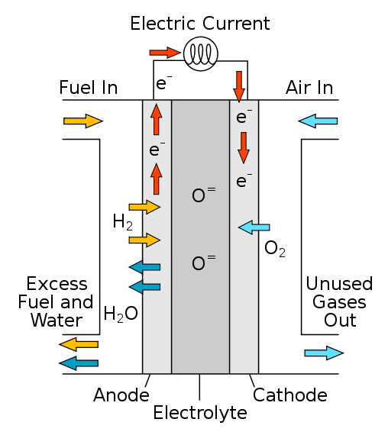

_____________________________________________________________________________

_____________________________________________________________________________

_____________________________________________________________________________

_____________________________________________________________________________

_____________________________________________________________________________

_____________________________________________________________________________

_____________________________________________________________________________

_____________________________________________________________________________

_____________________________________________________________________________

_____________________________________________________________________________

_____________________________________________________________________________

_____________________________________________________________________________

_____________________________________________________________________________

1. Describe and explain 3 different limitations/disadvantages of the fuel cell. **(3 marks)**
2. ____________________________________________________________________

____________________________________________________________________

1. ____________________________________________________________________

____________________________________________________________________

1. ____________________________________________________________________

____________________________________________________________________

**Question 3**

A group of students perform a series of experiment’s where the voltage of various cells were measured.

**Table 1: The recorded voltage for various electrochemical cells**

|  |  |
| --- | --- |
| Cell cations | Measured Voltage (volts) |
| Ag//Ag+ Cu//Cu2+ | 1.14 V |
| Cu//Cu2+ Sn//Sn2+ | 0.20 V |
| Sn//Sn2+ Ag//Ag+ | 0.94 V |
| Ag//Ag+ Mg//Mg2+ | 3.16 V |
| Cu//Cu2+ Mg//Mg2+ | 2.02 V |

1. Graph the results. **(4 marks)**
2. Another group of students measured a sixth cell and measured the voltage. The cell involved Mg//Mg2+ and an unknown metal. The voltage measured was +3.81V.

What is the unknown metal and account for the voltage? **(3 marks)**

___________________________________________________________________

___________________________________________________________________

___________________________________________________________________

___________________________________________________________________

1. Another group planned to do another series of electrochemical cells. The following is the list of their equipment.

**List 1: Electrochemical Cells Equipment**

Metal strips - nickel, cobalt, iron, chromium, silver and aluminium

Metal solutions 0.001 M - nickel sulfate

- cobalt chloride

- chromium iodide

- silver hydroxide

- aluminium nitrate

Filter paper

Salt bridge solution – 0.1 M sodium chloride

100 mL beakers

1. Critique the list. **(3 marks)**

____________________________________________________________________

____________________________________________________________________

____________________________________________________________________

____________________________________________________________________

____________________________________________________________________

____________________________________________________________________

1. Create a table and enter the theoretical data. **(3 marks)**

**Marks: ______/34 Marks**